July 28, 2023
SAVE THE DATE for the 2023-2024 Howard County High School Food Drive Competition!

To Whom It May Concern:

I hope this correspondence finds you in the best of health and spirit.
The Howard County Office of Human Rights & Equity and the Howard County Martin Luther King Jr. Holiday Commission invite you to participate in the 2023-2024 Howard County High School Food Drive Competition. For your reference, the Office of Human Rights & Equity’s EIN number is: 52-6000965
For the past four years, the MLK Commission has coordinated this food drive competition and raised donations for the Howard County Food Bank. This competition has garnered over 9,000 pounds of food for needy families in Howard County.
This year's competition will run from Monday, October 2, 2023 to Wednesday, November 1, 2023 with the objective of collecting non-perishable food items and baby products prior to the holiday season. The high school that raises the most amount of food will be recognized at the annual Howard County MLK Day Celebration on January 14th and receive a banner recognizing their accomplishment.
The MLK Commission is committed to ensuring that every Howard County high school participates in this worthwhile cause. If a club, team, chapter, or other organization from your school is interested in sponsoring this year's food drive competition, please contact Student Commissioners Tabitha Dixon, Ishaan Busireddy, and Commissioner Hunter Craig at tabithadixon808@gmail.com, ishaanbusireddy@gmail.com, & huntercraig71108@gmail.com with your school’s point of contact.
Thank you and we look forward to having your participation.

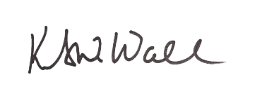
Sincerely,

Kurt Wall,
Chair
Howard County Martin Luther King, Jr. Holiday Commission

