GLENWOOD MIDDLE SCHOOL
2019-2020 SCHOOL YEAR
GRADE 6 SUPPLY LIST

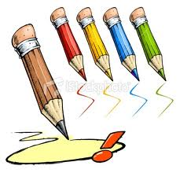
- 1 box colored pencils (erasable if possible)
- 2 packs index cards (100 pack)
- 2 colors of highlighters
- 2 sets dividers
- 1 composition book for English
- felt fine-tip pen in red, blue and black
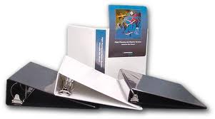
- red pen
- glue sticks
- ruler (metric if possible)
- pencils/blue or black pen as needed
- 3 packs of loose leaf paper – refilled as needed
- steno pad
- two different colored 2-inch binders
- student planner/agenda book provided by GMS on first day of school
- suggested but not required: pencil case and white board marker
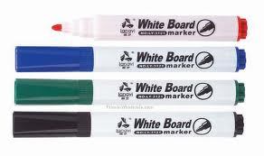
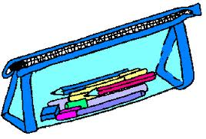

- Additional needs for those students in GT Research class: 1 - 2-inch 3 ring binder and another set of dividers

NOTE: Rolling backpacks and large/zippered binders DO NOT fit in lockers.

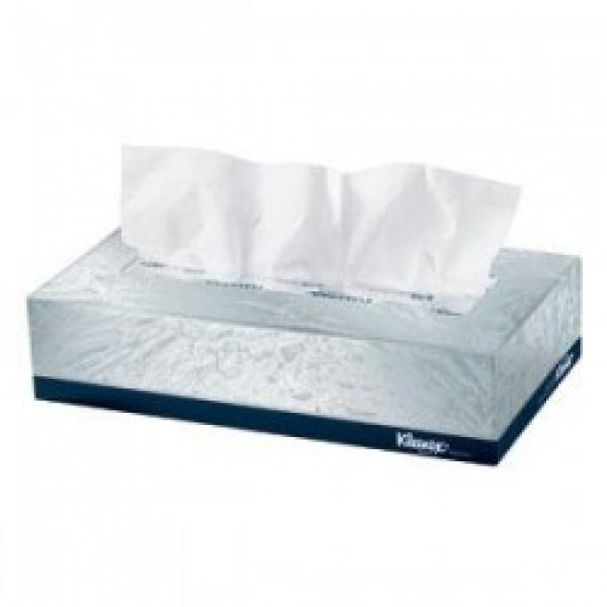
DONATIONS OF TISSUE BOXES TO HOMEROOM TEACHERS WOULD BE GREATLY APPRECIATED, BUT NOT REQUIRED – PLEASE LABEL BOX: 6th GRADE HOMEROOM TEACHER. THANK YOU.

